4.1 Instruction for running video player and video-player-chrome-extension

4.1.1 : Instruction for running Video Player

Video Player is developed as a React App.
Prerequisite

- Node js (16)
- Yarn
- XT-Streaming package downloaded from Github

A To configure the Video Player

- Go to the Video_Player folder
- Open src / config.json

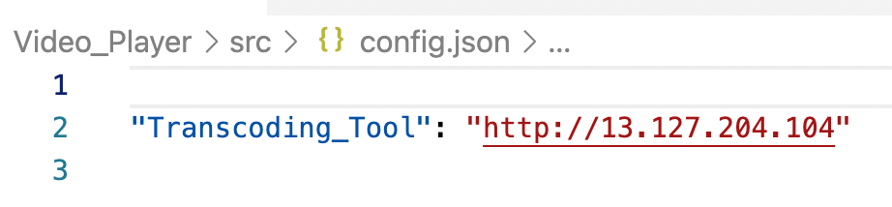

Update the Transcoding_Tool Url

B To install required dependencies for video_player

- Open terminal at the root of Video_Player folder and run command
- yarn or npm install

C To run video player

- Open terminal at the root of Video_Player folder and run command
- yarn start or npm start

Video player should be running at http://localhost:3000

D Video Player Build (To be hosted on a Web server)

- Go to Video_Player directory
- Open terminal run yarn build or npm run build
- For standalone hosting as a SPA, copy the contents inside the build folder to the root of any webserver.

4.1.2: Instruction for running video player chrome extension

A Video Player Chrome Extension (Setting up)

- Take the code build as per 4.1.1(D)
- Copy the contents inside the build folder created in the guide, to the Xtstreaming_Client_Chrome_Extension folder

- 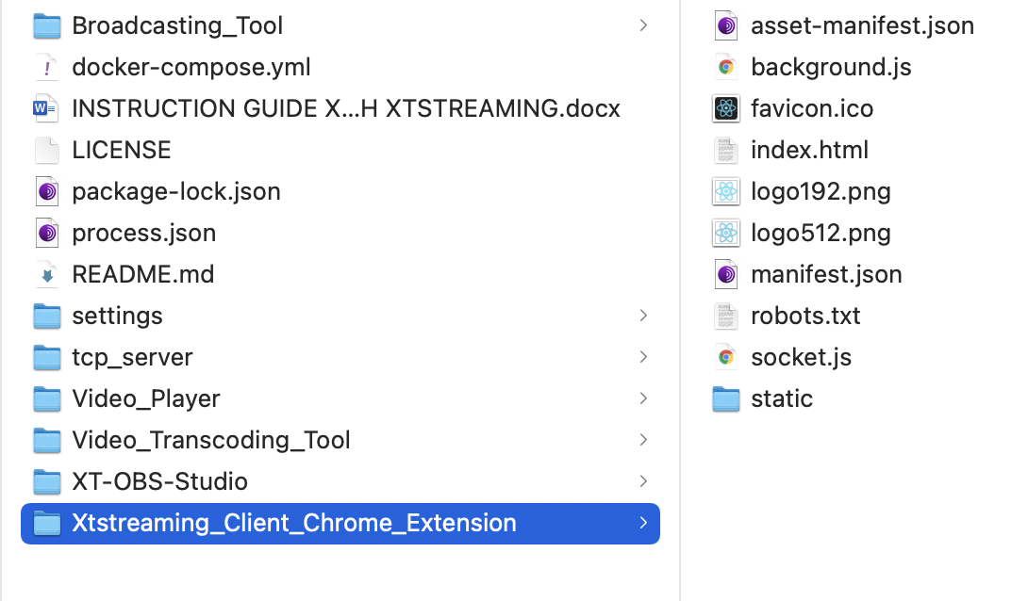
- Open google chrome
- Open settings > More Tools > extension

- Click on load unpacked select Xtstreaming_Client_Chrome_Extension folder

4.1.3 Video Player Chrome Extension (for testing)
- Xtstreaming_Client_Chrome_Extension already contains the build files which can be uploaded to the chrome extension directly.

